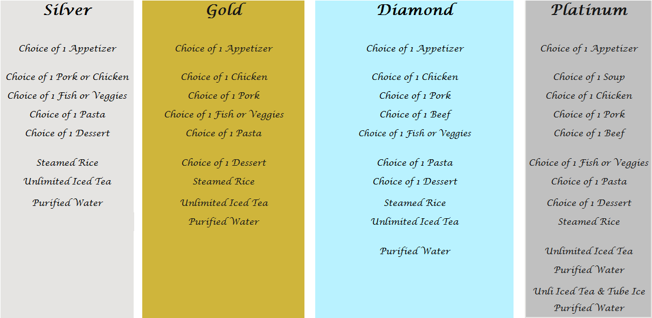

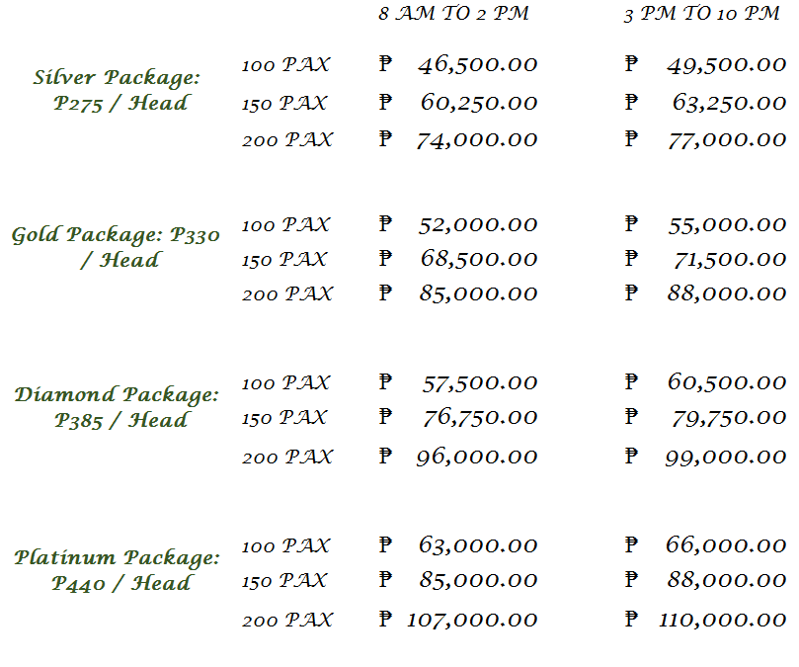

INCLUSION:
- 3 hours use of Garden or Swimming Pool Venue
- Food with catering service
- Garden or Hawaiian Venue Setup and Stage backdrop with Signage entrance
- 3 layered Cake
- 2 Glass of Sparkling Wine
- Food tasting for 2 persons
- 4 Air Coolers for 3 hours
- 1 Reception Coordinator
- Overnight accommotion in Garden Room for 2 with Breakfast
- 1 Non Aircondition room for the suppliers or 10 persons swimming at the Infinity pool of Leticia’s Garden Resort
- 30% discount on additional rooms and 20% on Private Pool Package

Menu
