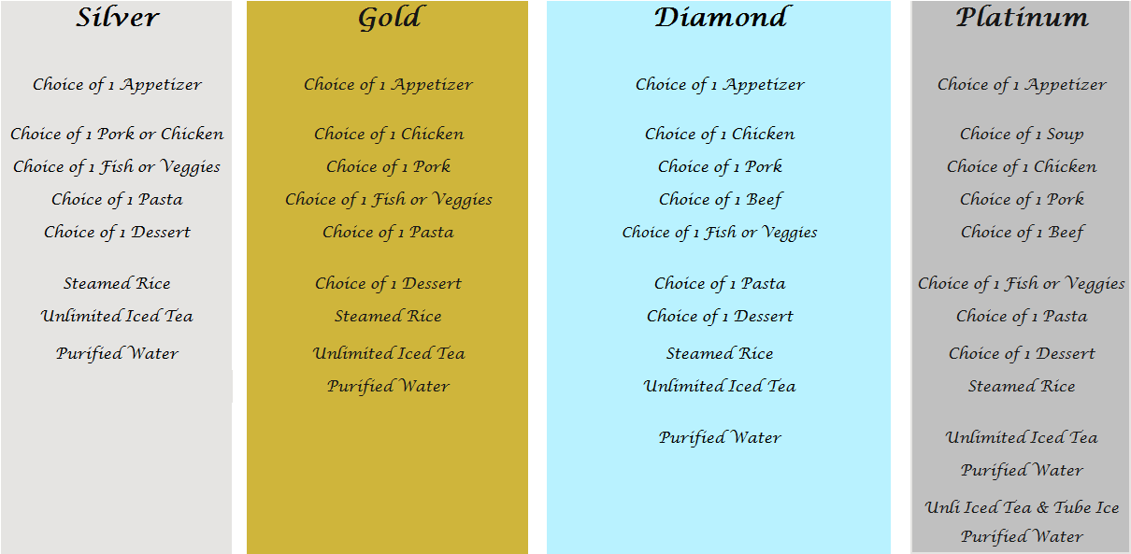

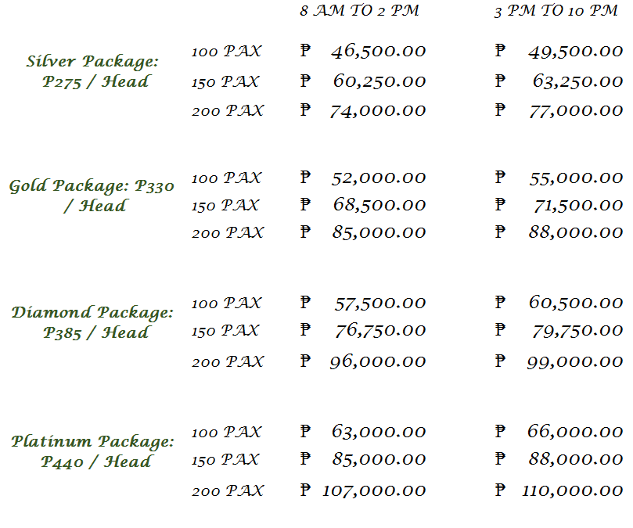

INCLUSION:
- 3 hours use of Garden or Swimming Pool Venue
- Food with Catering Service
- 3 Layered Cake
- Garden or Hawaiian Setup Venue with Stage Backdrop and Signage Entrance
- 4 Air Coolers 3 hours use
- Reception Coordinator
- Food tasting for 2 persons
- 1 Garden Room overnight accommodation for 2 persons with Breakfast
- 1 Non-airconditioned Room for the supplier or 10 persons free swimming entrance at Leticias Garden Resort for 5 hours
- 30% discount for additional Rooms and 20% on Private Pool Packages
MENU

